Bayes factor

Intro

Def

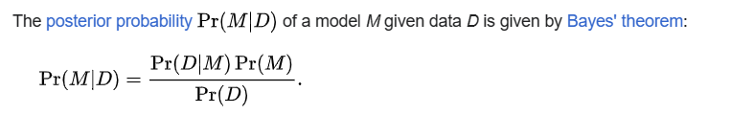

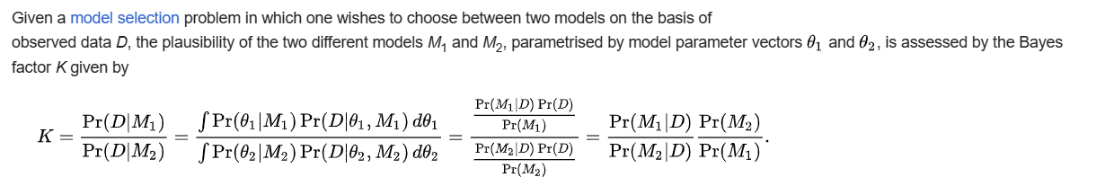

Ref

[Bayes factor - Wikipedia](https://en.wikipedia.org/wiki/Bayes_factor)